**KoneruLakshmaiah Education Foundation**

**(Deemed to be University)**

**DEPARTMENT OF COMPUTER SCIENCE AND ENGINEERING**

**A Project Based Lab Report**

**On**

**RAILWAY TICKET BOOKING SYSTEM**

**SUBMITTED BY:**

I.D NUMBER NAME

180030360 K.MOHAN SAI

**UNDER THE GUIDANCE OF**

**Dr.N. RAVINDER**

**Assistant professor**



**KL UNIVERSITY**

Green fields, Vaddeswaram – 522 502

Guntur Dt., AP, India.

**DEPARTMENT OF COMPUTER SCIENCE AND ENGINEERING**



**CERTIFICATE**

This is to certify that the project based laboratory report entitled “**RAILWAY TICKET BOOKING SYSTEM**” submitted by Mr**. K.MOHAN SAI** bearing Regd . No.**180030360** to the **Department Of BES-2, KL University** in partial fulfillment of the requirements for the completion of a project based Laboratory in “OBJECT ORIENTED PROGRAMMING SYSTEM “course in 2 B Tech 1 Semester, is a bonafide record of the work carried out by him/her under my supervision during the academic year 2019 – 2020.

PROJECT SUPERVISOR HEAD OF THE DEPARTMENT

Dr.N.RAVINDER Dr. V.HARI KIRAN

**ACKNOWLEDGEMENTS**

It is great pleasure for me to express my gratitude to our honorable President **Sri. Koneru Satyanarayana**, for giving the opportunity and platform with facilities in accomplishing the project based laboratory report.

I express the sincere gratitude to our principal **Prof Dr. K.Subba Rao** for his administration towards our academic growth.

I express sincere gratitude to HOD-CSE **Dr.V.HARI KIRIN** for his leadership and constant motivation provided in successful completion of our academic semester. I record it as my privilege to deeply thank for providing us the efficient faculty and facilities to make our ideas into reality.

I express my sincere thanks to our project supervisor N.RAVINDER for his/her novel association of ideas, encouragement, appreciation and intellectual zeal which motivated us to venture this project successfully.

Finally, it is pleased to acknowledge the indebtedness to all those who devoted themselves directly or indirectly to make this project report success.

IDNO Name

180030360 K.MOHAN SAI

**ABSTRACT**

[**Abstract Objective**: Designing the application and of Railway Reservation System for the purpose of reserving railway ticket sand database maintenance about train and passenger details by the railway department only. This database helps railways to retrieve data as and when required in future. The scope of project included evaluation of the application and was primarily concerned with the transactions related to booking of tickets from the terminals operated by the railway personnel. Application controls and simulation were used to evaluate data validation and program logic. The selected data, as made available, for substantive checking of the completeness, integrity and consistency of data using computer assisted applications such as VB, MS Access. The records maintained in the database of the railways reservation centre were also reviewed. Discussions were held with the database users to gain understanding regarding the various functional aspects of the system. The booking database has passenger%E2%80%99s details like Name, Age, Gender, Total Number of PassengersTraveling, Date of Travel, and Class of Travel.The train database has train details like Train Name, Train Number, Route, From, To, Train Time, ACFirst Class, AC 2 Tier, AC](abstractobjective:Designing%20the%20application%20and%20of%20Railway%20Reservation%20System%20for%20the%20purpose%20of%20reservingrailwayticketsand%20database%20maintenance%20about%20train%20and%20passenger%20details%20by%20the%20railwaydepartment%20only.%20This%20database%20helps%20railways%20toretrieve%20dataas%20and%20when%20required%20in%20future.The%20scope%20of%20project%20included%20evaluation%20of%20the%20application%20and%20was%20primarily%20concerned%20with%20thetransactions%20related%20to%20booking%20of%20tickets%20fromthe%20terminals%20operated%20by%20the%20railway%20personnel.%20Application%20controls%20and%20simulation%20were%20used%20to%20evaluatedata%20validationand%20program%20logic.%20Theselected%20data,%20as%20made%20available,%20for%20substantive%20checking%20of%20the%20completeness,%20integrity%20andconsistency%20of%20data%20using%20computer%20assisted%20applications%20such%20as%20VB,%20MS%20Access.The%20records%20maintained%20in%20the%20database%20of%20the%20railways%20reservation%20centre%20were%20also%20reviewed.Discussions%20were%20held%20with%20the%20database%20users%20to%20gain%20understanding%20regarding%20the%20various%20functionalaspects%20of%20the%20system.The%20booking%20database%20has%20passenger%E2%80%99s%20details%20like%20Name,%20Age,%20Gender,%20Total%20Number%20of%20PassengersTraveling,%20Date%20of%20Travel,%20and%20Class%20of%20Travel.The%20train%20database%20has%20train%20details%20like%20Train%20Name,%20Train%20Number,%20Route,%20From,%20To,%20Train%20Time,%20ACFirst%20Class,%20AC%202%20Tier,%20AC)

**INDEX**

|  |  |  |
| --- | --- | --- |
| **S.NO** | **TITLE** | **PAGE NO** |
| 1 | Introduction | 6 |
| 2 | Aim of the Project | 9 |
| 2.1 | Advantages & Disadvantages | 9 |
| 2.2 | Future Implementation | 9 |
| 3 | Software & Hardware Details | 10 |
| 4 | Data Flow Diagram | 11 |
| 5 | Implementation | 15 |
| 6 | Algorithm | 17 |
| 7 | Integration and System Testing | 32 |
| 8 | Conclusion | 34 |

**INTRODUCTION**

This project deals with reserving tickets for the trains which is heck these days. So inorder to make it convenient to travel we can book, cancel, display reservation chart, search passenger number and display un booked tickets. This makes the travel smooth and convenient. This also helps in checking the details afterwards.

The train ticket booking system is a Java project which maintains the ticket booking and other heavy works of a train station. This system is very much easy and is user-friendly. Anyone can use this system without any difficulty. As back-end support MySQL database is used and NetBeans IDE for its user interface design. Before you run this project make sure you have the JDK and JRE installed on your system..

**We are using java swings concept for this project**

**Java swings:**

**Java Swing tutorial** is a part of Java Foundation Classes (JFC) that is used to create window-based applicarions. It is built on the top of AWT (Abstract Windowing Toolkit) API and entirely written in java.

Unlike AWT, Java Swing provides platform-independent and lightweight components.

The javax.swing package provides classes for java swing API such as JButton, JTextField, JTextArea, JRadioButton, JCheckbox, JMenu, JColorChooser etc

The hierarchy of java swing API is given below.

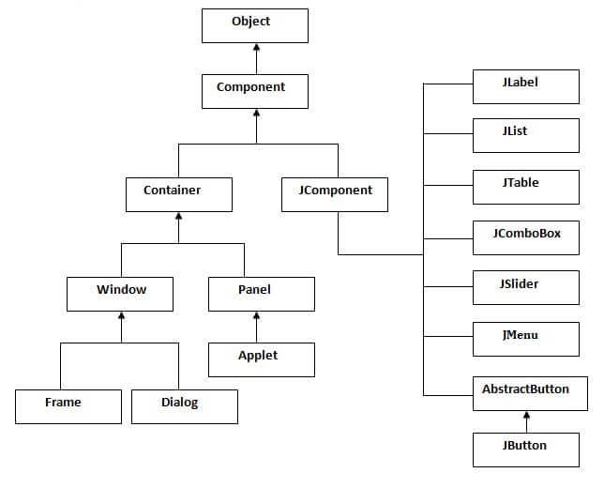

**Java if,else if:**

Decision Making in programming is similar to decision making in real life. In programming also we face some situations where we want a certain block of code to be executed when some condition is fulfilled.  
A programming language uses control statements to control the flow of execution of program based on certain conditions. These  are used to cause the flow of execution to advance and branch based on changes to the state of a program.

These statements allow you to control the flow of your program’s execution based upon conditions known only during run time.

* **if**: if statement is the most simple decision making statement. It is used to decide whether a certain statement or block of statements will be executed or not i.e if a certain condition is true then a block of statement is executed otherwise not.
* **if-else**: The if statement alone tells us that if a condition is true it will execute a block of statements and if the condition is false it won’t. But what if we want to do something else if the condition is false. Here comes the else statement. We can use the else statement with if statement to execute a block of code when the condition is false.

**Java Strings:**

Strings are defined as an array of characters. The difference between a character array and a string is the string is terminated with a special character ‘\0’. Whenever a String Object is created, two objects will be created- one in the Heap Area and one in the String constant pool and the String object reference always points to heap area object.

**AIM**

**AIM**:Implementation of Railway Reservation system.

**Advantages:-**

The various advantages of using the online reservation system are as follows: Convenient – You can book or cancel your tickets sitting in the comfort of your home or office. Saves Time and Effort - You can save the time needed to travel to the railway reservation office and waiting in the queue for your turn.

**Disadvantages:-**

Late bookings**,** Unsuitable for Short Distances, Unsuitable for Rural Areas

**Future enhancements:-**

Railway ticket booking is the most toughest part for any train traveller

To wait in queues for a long time makes the person so stressed this

Can be used for the online booking to reduce the stress and work in an productive manner.

**SYSTEM REQUIREMENTS**

* **SOFTWARE REQUIREMENTS:**

The major software requirements of the project are as follows:

Language : JAVA

Operating system**:**Windows Xp or later.

* **HARDWARE REQUIREMENTS:**

The hardware requirements that map towards the software are as follows:

RAM : 8GB DDR4 2400RPM

Processor : Intel i5 74

**DATA FLOW DIAGRAM**

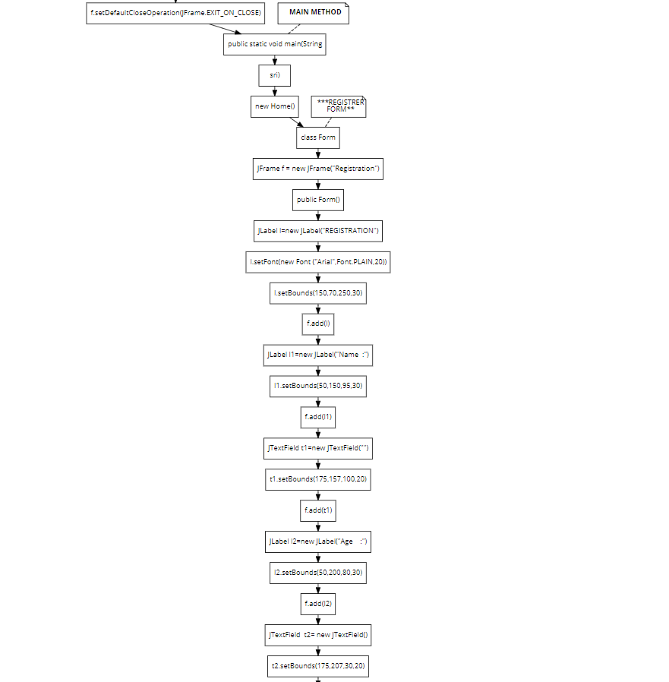

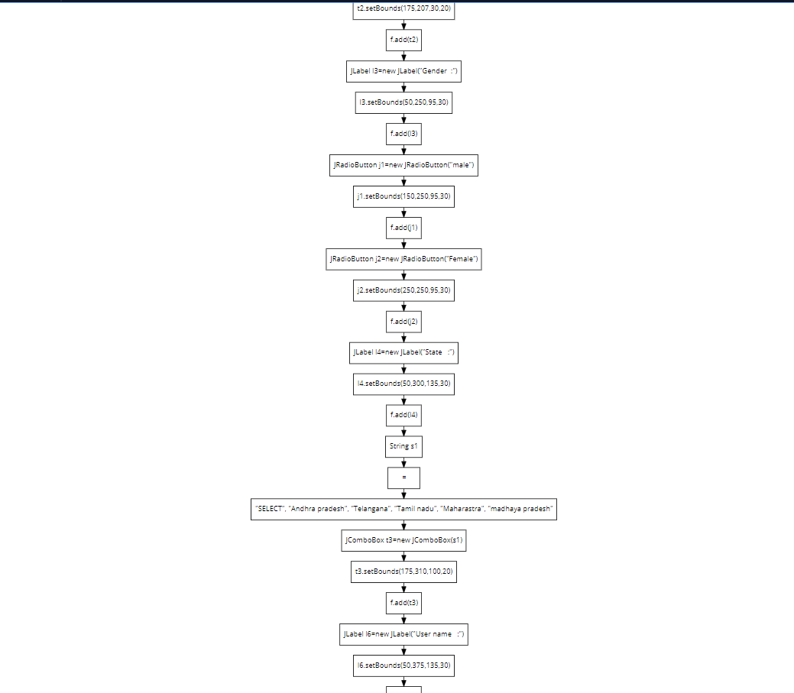

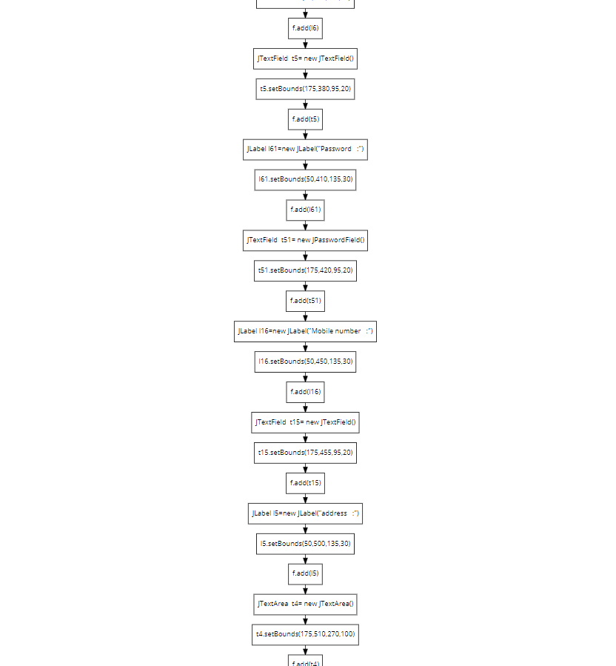

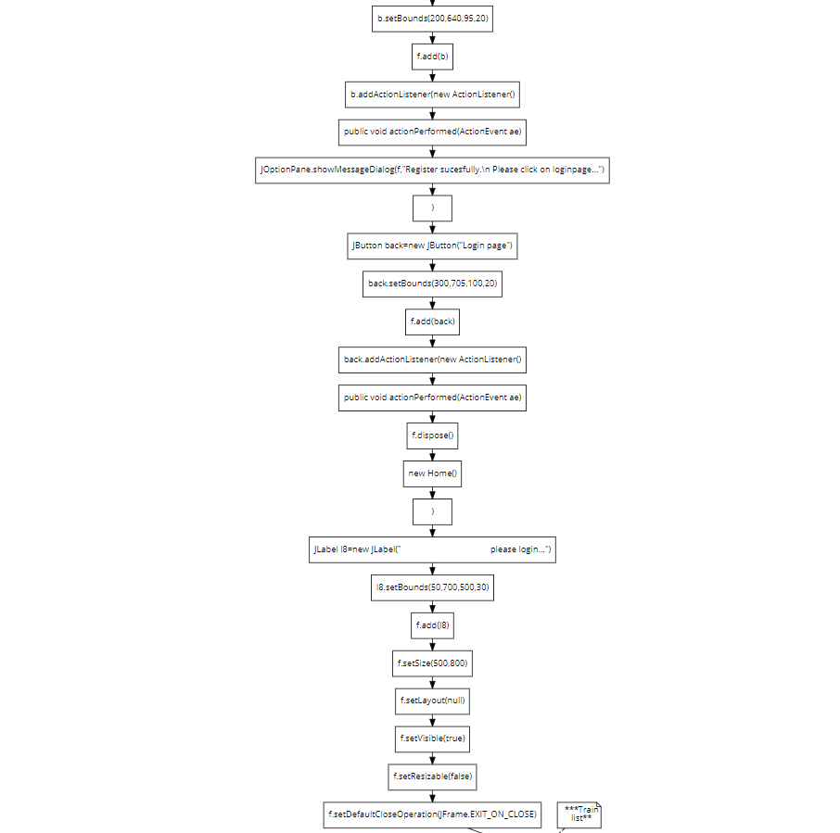

**ALGORITHM**

Now step by step booking process

1.I am a 23, Male, I enter my details and I have written preference for the Upper berth. There are 18 UB in each sleeper Coach, total upper berths= 180, In tatkal 20% gone. Thus left over is 144 Berths. The system will allot the berth to all 144 persons without an exception in different Sleeper coaches. After Upper Berth is filled they start giving in Middle Berth and Side upper Berth, But in that some seats are left to be filled at the time of chart preparation.

2.Suppose there is a couple who booked ticket but it was in waiting and it got confirmed in chart reservation, Now they will be allotted tickets in and around same coupe or two middle berths. They are not alloted Berths together most of the time. Suppose like Lower and Middle, or Side Lower and Side upper

3.Seat allotment goes according to the choices of user untill less than 100 seats are left. After that time UB might get exhausted, so MB and Side upper berth starts filling. Generally it is seen that Side upper berths which are above RAC berths are given to the single Males having age above 21

4.RAC Berths are Divided like following

2-4=> 2AC

4-6=> 3AC

8-12=> Sleeper

RAC allotments are given to passengers after all the seats have been allotted despite their choices. Suppose there were two seats available when I booked for a group of 4. 2 people will get confirm berth, they might be given in different coaches too depending upon availability. 2 people will get RAC and it will be shown RAC-1 and RAC-2, Once somebody cancels their status will become CNF but seat will be allotted after chart preparation only

5.Most of the railway bookings are done in pairs when it is ending, Suppose two people book tickets together then it is most likely that they will get two middle berths opposite to each other rather than Lower Middle or Side upper and lower combo. And suppose if Side upper is available and Side Lower is not available then mostly Middle Berth pair is given.

It is a notable fact that I have seen most couple travel in Middle Berth opposite seats

6.Only 20-30% seats are open for Lower berth preferences for Males and that too aged more than 21. Most of these berths are given to old age people and women. In rare cases Senior citizen are alloted UB, it is only done if the only seat available is upper berth

7.A special care is taken that a female is not left alone in a coupe during chart preparation, Mostly females are clubbed together and Female coupe can be well defined in the train. If they are not able to allot like that and suppose a single female 22 got a UB in a Coupe, then the most probable event is that either a family will come or other single female traveller will come in Coupe, If not so then females from Tatkal are allotted seats in that coupe. In no circumstances railways leaves women alone in coupe

Now step by step booking process

1.I am a 23, Male, I enter my details and I have written preference for the Upper berth. There are 18 UB in each sleeper Coach, total upper berths= 180, In tatkal 20% gone. Thus left over is 144 Berths. The system will allot the berth to all 144 persons without an exception in different Sleeper coaches. After Upper Berth is filled they start giving in Middle Berth and Side upper Berth, But in that some seats are left to be filled at the time of chart preparation.

2.Suppose there is a couple who booked ticket but it was in waiting and it got confirmed in chart reservation, Now they will be allotted tickets in and around same coupe or two middle berths. They are not alloted Berths together most of the time. Suppose like Lower and Middle, or Side Lower and Side upper

3.Seat allotment goes according to the choices of user untill less than 100 seats are left. After that time UB might get exhausted, so MB and Side upper berth starts filling. Generally it is seen that Side upper berths which are above RAC berths are given to the single Males having age above 21

4.RAC Berths are Divided like following

2-4=> 2AC

4-6=> 3AC

8-12=> Sleeper

RAC allotments are given to passengers after all the seats have been allotted despite their choices. Suppose there were two seats available when I booked for a group of 4. 2 people will get confirm berth, they might be given in different coaches too depending upon availability. 2 people will get RAC and it will be shown RAC-1 and RAC-2, Once somebody cancels their status will become CNF but seat will be allotted after chart preparation only

5.Most of the railway bookings are done in pairs when it is ending, Suppose two

a family will come or other single female traveller will come in Coupe, If not so then females from Tatkal are allotted seats in that coupe. In no circumstances railways **IMPLEMENTATION**

import javax.swing.*;

import java.awt.event.*;

import java.awt.*;

//****************************************** Loginpage ********************************************

class Home

{

Home()

{

JFrame f=new JFrame("HOME");

JLabel l11=new JLabel(" - TRAIN TICKET BOOKING -");

l11.setBounds(300,105,500,30);

l11.setFont(new Font ("Arial",Font.PLAIN,20));

f.add(l11);

//*** username and passowrd ***

JLabel l1=new JLabel("User name");

l1.setBounds(340,200,95,30);

f.add(l1);

JTextField t1=new JTextField("");

t1.setBounds(440,200,130,30);

f.add(t1);

JLabel l2=new JLabel("Password");

l2.setBounds(340,250,95,30);

f.add(l2);

JPasswordField t2=new JPasswordField("");

t2.setBounds(440,250,130,30);

f.add(t2);

//***Login button***

JButton b=new JButton("Login");

b.setBounds(455,305,95,30);

f.add(b);

b.addActionListener(new ActionListener() {

public void actionPerformed(ActionEvent ae) {

String uname=t1.getText();

String psd=t2.getText();

if (uname.equals("klu") && psd.equals("123"))

{

b.addActionListener(new ActionListener() { public void actionPerformed(ActionEvent ae) {

f.dispose();

new Train();

}

});

}

else

{

JOptionPane.showMessageDialog(f,"Invalid username or password");

}

}

});

JLabel l3=new JLabel("Don't have a account..?");

l3.setBounds(340,370,140,50);

f.add(l3);

JButton b1=new JButton("Register");

b1.setBounds(475,385,85,20);

f.add(b1);

b1.addActionListener(new ActionListener() {

public void actionPerformed(ActionEvent ae) {

f.dispose();

new Form();

}

});

f.setSize(900,600);

f.setLayout(null);

f.setVisible(true);

f.setResizable(false);

f.setDefaultCloseOperation(JFrame.EXIT_ON_CLOSE);

}

// **** MAIN METHOD ****

public static void main(String[] sri)

{

new Home();

}

}

//***************************REGISTRER FORM************************************

class Form {

JFrame f = new JFrame("Registration");

public Form()

{

JLabel l=new JLabel("REGISTRATION");

l.setFont(new Font ("Arial",Font.PLAIN,20));

l.setBounds(150,70,250,30);

f.add(l);

JLabel l1=new JLabel("Name :");

l1.setBounds(50,150,95,30);

f.add(l1);

JTextField t1=new JTextField("");

t1.setBounds(175,157,100,20);

f.add(t1);

JLabel l2=new JLabel("Age :");

l2.setBounds(50,200,80,30);

f.add(l2);

JTextField t2= new JTextField();

t2.setBounds(175,207,30,20);

f.add(t2);

JLabel l3=new JLabel("Gender :");

l3.setBounds(50,250,95,30);

f.add(l3);

JRadioButton j1=new JRadioButton("male");

j1.setBounds(150,250,95,30);

f.add(j1);

JRadioButton j2=new JRadioButton("Female");

j2.setBounds(250,250,95,30);

f.add(j2);

JLabel l4=new JLabel("State :");

l4.setBounds(50,300,135,30);

f.add(l4);

String s1[] = {"SELECT", "Andhra pradesh", "Telangana", "Tamil nadu", "Maharastra", "madhaya pradesh" };

JComboBox t3=new JComboBox(s1);

t3.setBounds(175,310,100,20);

f.add(t3);

JLabel l6=new JLabel("User name :");

l6.setBounds(50,375,135,30);

f.add(l6);

JTextField t5= new JTextField();

t5.setBounds(175,380,95,20);

f.add(t5);

JLabel l61=new JLabel("Password :");

l61.setBounds(50,410,135,30);

f.add(l61);

JTextField t51= new JPasswordField();

t51.setBounds(175,420,95,20);

f.add(t51);

JLabel l16=new JLabel("Mobile number :");

l16.setBounds(50,450,135,30);

f.add(l16);

JTextField t15= new JTextField();

t15.setBounds(175,455,95,20);

f.add(t15);

JLabel l5=new JLabel("address :");

l5.setBounds(50,500,135,30);

f.add(l5);

JTextArea t4= new JTextArea();

t4.setBounds(175,510,270,100);

f.add(t4);

JButton b=new JButton("Submit");

b.setBounds(200,640,95,20);

f.add(b);

b.addActionListener(new ActionListener() {

public void actionPerformed(ActionEvent ae) {

{

JOptionPane.showMessageDialog(f,"Register sucesfully.\n Please click on loginpage...");

}

}

});

JButton back=new JButton("Login page");

back.setBounds(300,705,100,20);

f.add(back);

back.addActionListener(new ActionListener() {

public void actionPerformed(ActionEvent ae) {

f.dispose();

new Home();

}

});

JLabel l8=new JLabel(" please login...");

l8.setBounds(50,700,500,30);

f.add(l8);

f.setSize(500,800);

f.setLayout(null);

f.setVisible(true);

f.setResizable(false);

f.setDefaultCloseOperation(JFrame.EXIT_ON_CLOSE);

}

}

//***********************Train list**************************

class Train {

JFrame f = new JFrame("Trains list");

public Train()

{

JLabel l=new JLabel("Trains and Timings");

l.setFont(new Font ("Arial",Font.PLAIN,20));

l.setBounds(150,70,250,30);

f.add(l);

JLabel l1=new JLabel("Starting point :");

l1.setBounds(50,150,95,30);

f.add(l1);

JTextField t1=new JTextField("");

t1.setBounds(175,157,100,20);

f.add(t1);

JLabel l2=new JLabel("Destination point :");

l2.setBounds(50,170,150,95);

f.add(l2);

JTextField t2= new JTextField();

t2.setBounds(175,207,100,20);

f.add(t2);

JLabel l3=new JLabel("Gender :");

l3.setBounds(50,250,95,30);

f.add(l3);

JRadioButton j1=new JRadioButton("male");

j1.setBounds(150,250,95,30);

f.add(j1);

JRadioButton j2=new JRadioButton("Female");

j2.setBounds(250,250,95,30);

f.add(j2);

JLabel l4=new JLabel("Trains :");

l4.setBounds(50,300,135,30);

f.add(l4);

String s1[] = {"SELECT", "Seshadri express", "Shatabdi express", "Garib rath", "Vande Bharath express", "Vishaka express","Rajadhani express" };

JComboBox t3=new JComboBox(s1);

t3.setBounds(175,310,100,20);

f.add(t3);

JLabel l6=new JLabel("TIMINGS :");

l6.setBounds(50,370,135,30);

f.add(l6);

String s11[] = {"SELECT", "09:00AM", "09:55AM", "11:00AM", "12:30PM", "01:30PM", "02:55PM", "03:15PM", "04:52PM","06:00PM","08:00PM","10:00PM","11:55PM" };

JComboBox t33=new JComboBox(s11);

t33.setBounds(175,375,100,20);

f.add(t33);

JLabel l61=new JLabel("Seats :");

l61.setBounds(50,410,135,30);

f.add(l61);

JRadioButton j10=new JRadioButton("Upper");

j10.setBounds(150,410,95,30);

f.add(j10);

JRadioButton j20=new JRadioButton("LOWER");

j20.setBounds(250,410,95,30);

f.add(j20);

JLabel l16=new JLabel("Mobile number :");

l16.setBounds(50,450,135,30);

f.add(l16);

JTextField t15= new JTextField();

t15.setBounds(175,455,95,20);

f.add(t15);

JLabel l5=new JLabel("Select seat number :");

l5.setBounds(50,500,135,30);

f.add(l5);

String s111[] = {"SELECT", "s1", "s2", "s5", "s6", "s7", "s9", "s24", "s29","s37","s42","s48","s55","s59","s64","s79" };

JComboBox t330=new JComboBox(s111);

t330.setBounds(175,510,100,20);

f.add(t330);

JLabel l333=new JLabel("Ac/NON-AC");

l333.setBounds(50,550,130,30);

f.add(l333);

JRadioButton j11=new JRadioButton("AC");

j11.setBounds(150,550,95,30);

f.add(j11);

JRadioButton j22=new JRadioButton("NON-AC");

j22.setBounds(250,550,95,30);

f.add(j22);

JLabel l133=new JLabel("Train :");

l133.setBounds(50,600,130,30);

f.add(l133);

JRadioButton j111=new JRadioButton("EXPRESS");

j111.setBounds(150,600,95,30);

f.add(j111);

JRadioButton j222=new JRadioButton("SUPER FAST");

j222.setBounds(250,600,120,30);

f.add(j222);

JButton b=new JButton("Submit");

b.setBounds(200,660,95,20);

f.add(b);

b.addActionListener(new ActionListener() {

public void actionPerformed(ActionEvent ae) {

f.dispose();

new Details();

}

});

f.setSize(500,800);

f.setLayout(null);

f.setVisible(true);

f.setResizable(false);

f.setDefaultCloseOperation(JFrame.EXIT_ON_CLOSE);

}

}

//****************passenger details********************

class Details

{

JFrame f = new JFrame("PASSENGET DETAILS");

public Details()

{

JLabel l=new JLabel("PASSENGER DETAILS");

l.setFont(new Font ("Arial",Font.PLAIN,20));

l.setBounds(150,70,250,30);

f.add(l);

JLabel l1=new JLabel("Name :");

l1.setBounds(50,150,95,30);

f.add(l1);

JTextField t1=new JTextField("");

t1.setBounds(175,157,100,20);

f.add(t1);

JLabel l2=new JLabel("Age :");

l2.setBounds(50,200,80,30);

f.add(l2);

JTextField t2= new JTextField();

t2.setBounds(175,207,80,20);

f.add(t2);

JLabel l3=new JLabel("Gender :");

l3.setBounds(50,250,95,30);

f.add(l3);

JRadioButton j1=new JRadioButton("male");

j1.setBounds(150,250,95,30);

f.add(j1);

JRadioButton j2=new JRadioButton("Female");

j2.setBounds(250,250,95,30);

f.add(j2);

JLabel l6=new JLabel("Conform Password :");

l6.setBounds(50,300,150,30);

f.add(l6);

JTextField t5= new JPasswordField();

t5.setBounds(175,310,95,20);

f.add(t5);

JLabel l16=new JLabel("Mobile number :");

l16.setBounds(50,350,135,30);

f.add(l16);

JTextField t15= new JTextField();

t15.setBounds(175,360,95,20);

f.add(t15);

JLabel l5=new JLabel("Additional information :");

l5.setBounds(50,400,135,30);

f.add(l5);

JTextArea t4= new JTextArea();

t4.setBounds(195,410,240,80);

f.add(t4);

JButton b=new JButton("Submit");

b.setBounds(200,520,95,20);

f.add(b);

b.addActionListener(new ActionListener() {

public void actionPerformed(ActionEvent ae)

{ {

JOptionPane.showMessageDialog(f,"Succesfully Tickrt Booked.. \n Wish you happy journey...");

}

}

});

JButton back=new JButton("Login page");

back.setBounds(300,705,100,20);

f.add(back);

back.addActionListener(new ActionListener() {

public void actionPerformed(ActionEvent ae) {

f.dispose();

new Home();

}

});

JLabel l8=new JLabel(" Click here to Loginpage..........");

l8.setBounds(50,700,500,30);

f.add(l8);

f.setSize(500,800);

f.setLayout(null);

f.setVisible(true);

f.setResizable(false);

f.setDefaultCloseOperation(JFrame.EXIT_ON_CLOSE);

}

}

**INTEGRATION AND SYSTEM TESTING**

OUTPUTS

Screen Shots:

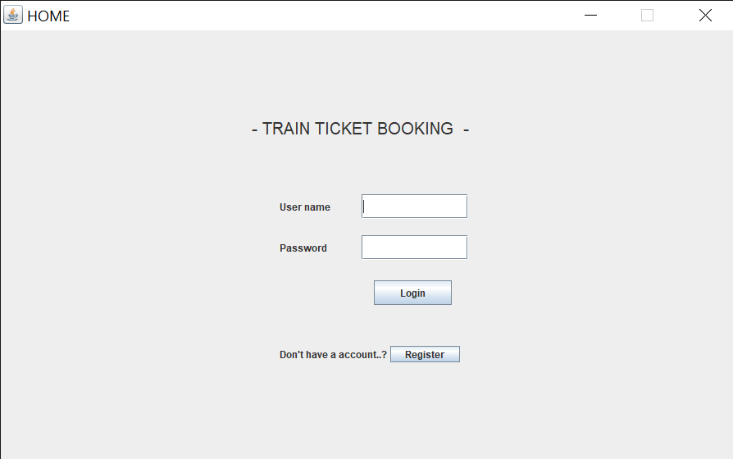

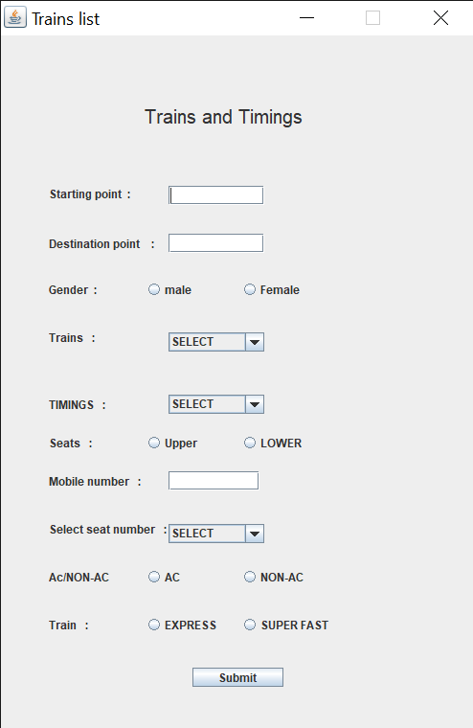

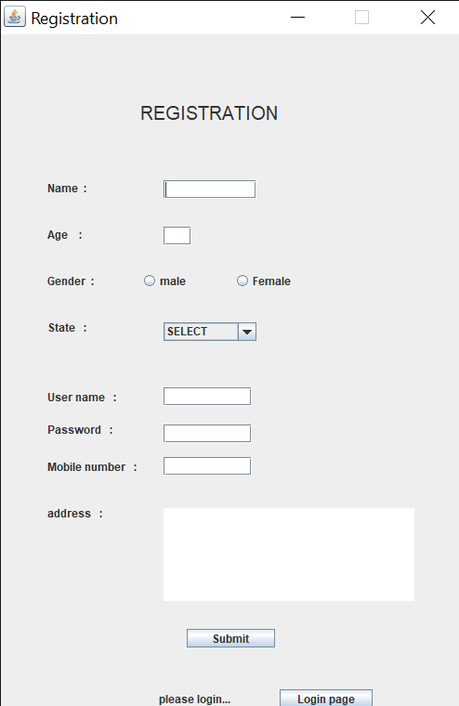

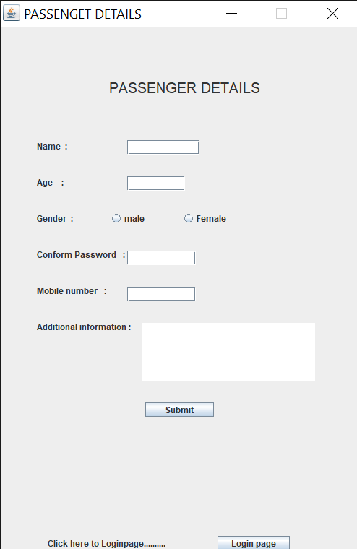

**CONCLUSION**

In our project: with this Railway ticketing system; Government can satisfy comfortable facilities to their customers. The relationship between manager, employee, and customer satisfy a good communication to complete ticketing process. With this platform we developed, we are hoping to reduce time wasting, avoid misunderstandings, provide easy data flow, customer pleasure, and less hard work. We believe that we have accomplished our goals and satisfied with the code we developed.